
Rajvardhan Zende
202501100016

SE 1 S11

ESSENTIALS OF DATA SCIENCE


PRACTICE LAB ASSIGNMENT
4.1.1. PANDAS - SERIES CREATION AND MANIPULATION
calculates the mean of evenandodd numbersseparatelyusing thegroupbyandmean()operations.
Hint: You can group the Series based on whether each number is even or odd.
Input Format:
The user should enter a list of numbers separated by space when prompted.
Output Format:
The program should display the mean of even and odd numbers separately.
Each mean value should be displayed with a label indicating whether it corresponds to even or odd numbers. Refer to the sample test cases for better understanding regarding input and output format.

INPUT OUTPUT

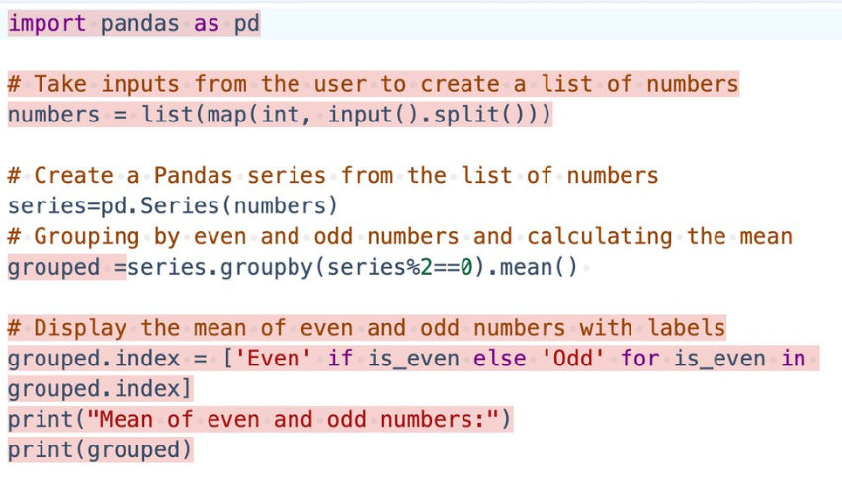

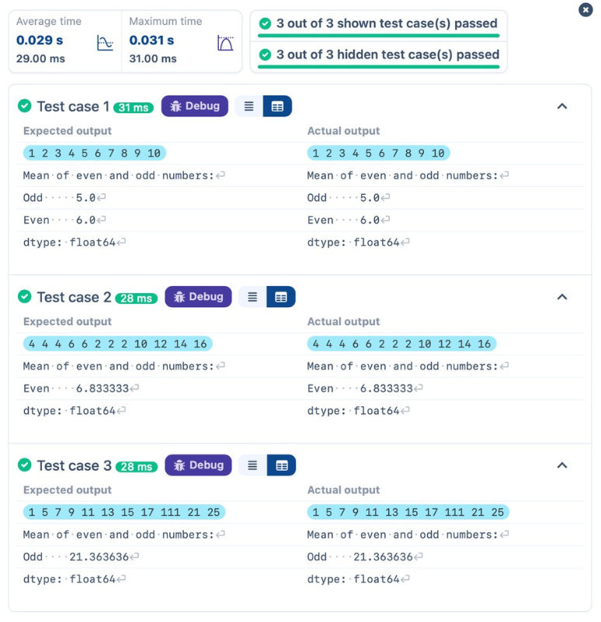


4.1.2. DICTIONARY TO DATAFRAME
Adictionary oflistshasbeenprovidedtoyouintheeditor.CreateaDataFramefromthedictionaryoflistsandperform the listed operations, then display the DataFrame beforeandaftereachmanipulation.
Create the DataFrame:
Convert the dictionary to a Pandas DataFrame.
Add a new row:
Take inputs from the user for the new row data (name, age).
Add the new row to the DataFrame.
Display the DataFrame after adding the new row.
Modify a row:
Modify a specific row by changing the age. Take the row index and new age value from the user.
Display the DataFrame after modifying the row.
Delete a row:
Take the row index to be deleted from the user.
Remove the specified row.
Display the DataFrame after deleting the row.
Add a new column:
Add a column Gender with values taken from the user.
Display the DataFrame after adding the new column.
Modify a column:
Convert names to uppercase.
Display the DataFrame after modifying the column.
Delete a column:
Remove the Age column.
Display the DataFrame after deleting the column.

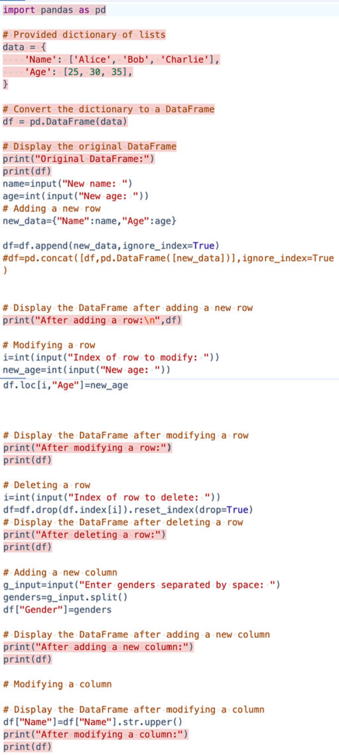

INPUT

OUTPUT
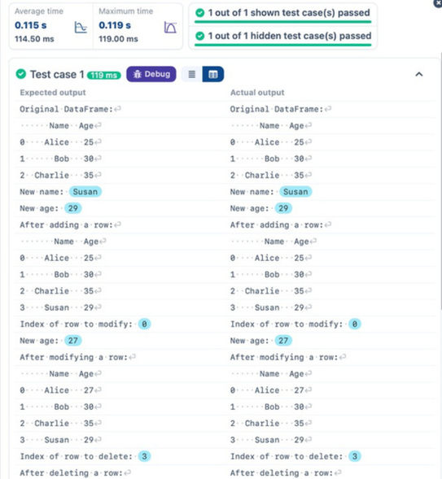
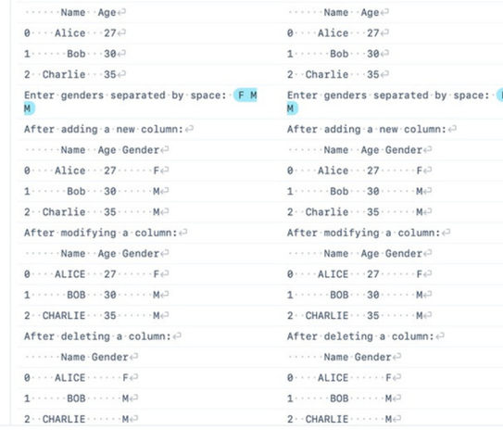

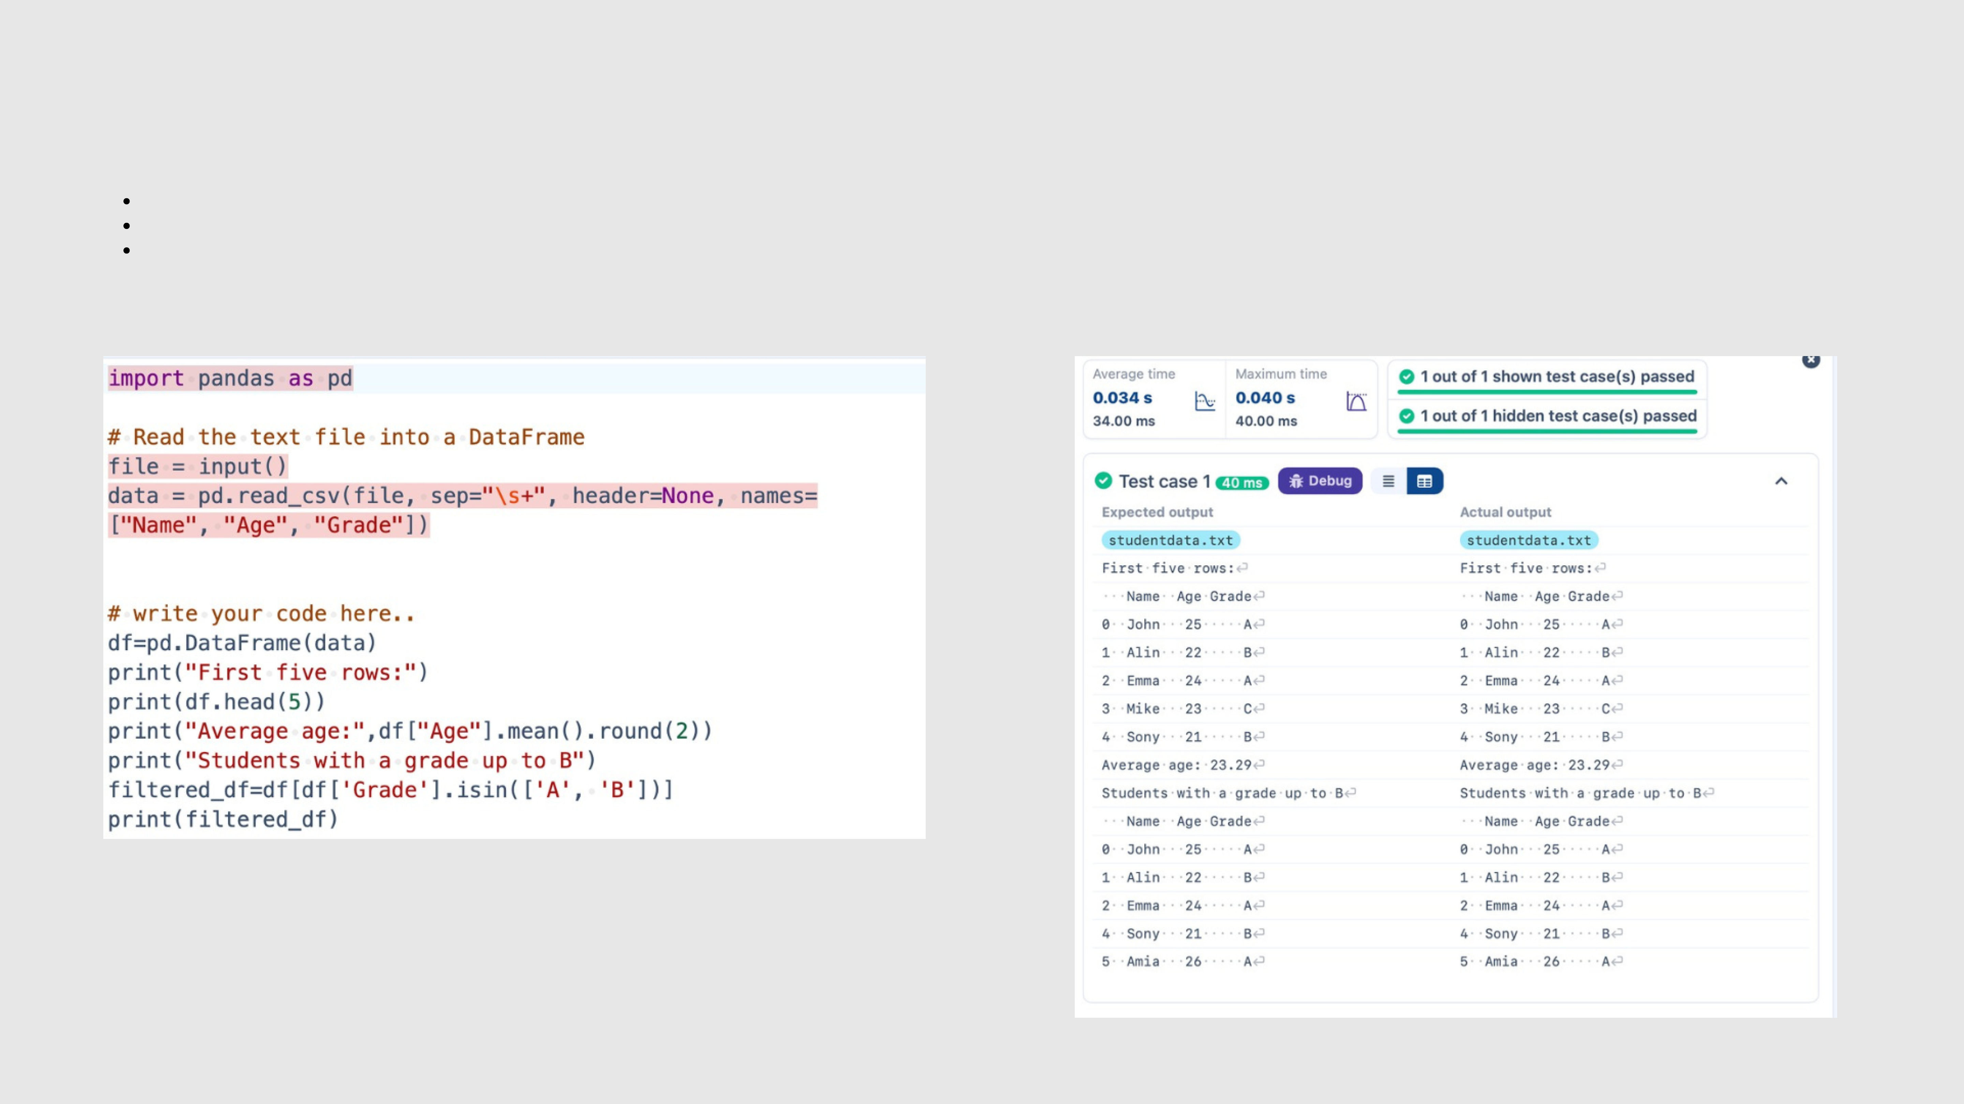
4.1.3. STUDENT INFORMATION
Writeaprogram toread atext filecontainingstudentinformation(name,age,andgrade)usingPandas.Perform the following tasks:
Displaythe firstfive rows of the dataframe.
Calculate the average age of the students (limit the average age up to 2 decimal places).
Filter out the students who have a grade above a certain threshold (consider the threshold grade is 'B').
INPUT OUTPUT


LAB ASSIGNMENT
4.2.1.MONTHWITHTHEHIGHESTTOTALSALES
Writea Python program that takes thefilename ofa CSVfile as input,readsthedata,andperformsthefollowingoperations: The CSV file contains the columns:Date, Product, Quantity, Price,andCity.
Groupthe data byMonth and calculate the total sales for eachmonth.
Find the month with the highest total sales and display it.
Also, display the total sales for the best month.
SampleData:
Date,Product,Quantity,Price,City
2025-01-01,Product A,5,20,New York
2025-01-01,Product B,3,15,Los Angeles
2025-01-02,Product A,7,20,New York
2025-01-02,Product C,4,30,Chicago
2025-01-03,Product B,2,15,Chicago
2025-01-03,Product A,8,20,Los Angeles
2025-01-04,Product C,6,30,New York
2025-01-04,Product B,5,15,Los Angeles
2025-01-05,Product A,3,20,Chicago
2025-01-05,Product C,10,30,Los Angeles

INPUT OUTPUT

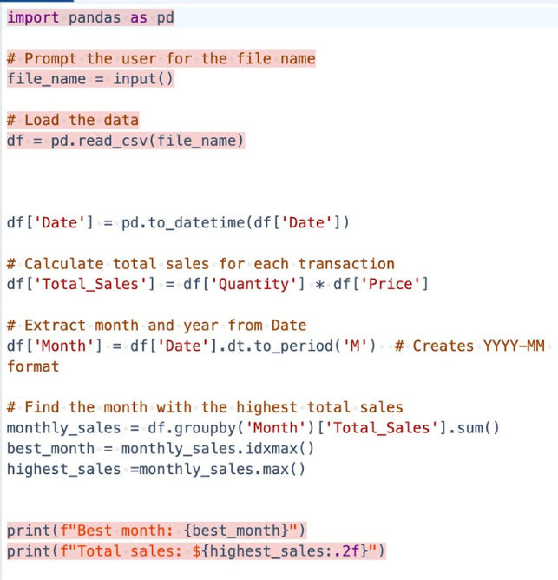

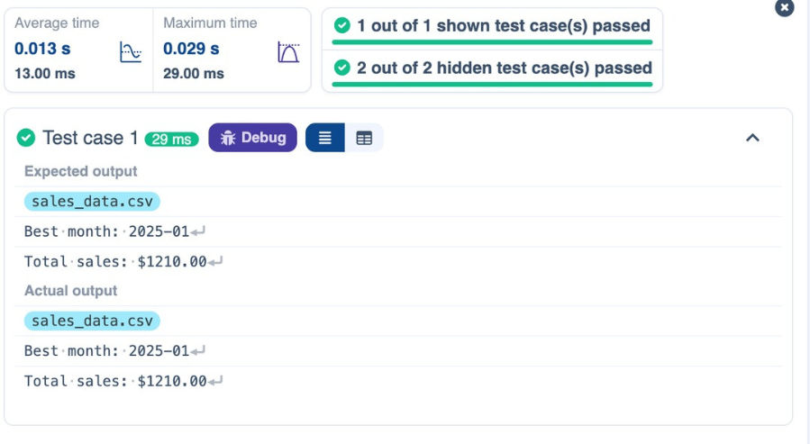


4.2.2. BEST SELLING PRODUCT
Write a Python program that takes the file name of a CSV file as input, reads the data, and performs the following operations: The CSV file contains the columns: Date, Product, Quantity, Price, and City.
Find the product that sold the most in terms of quantity sold.
Display the product that sold the most and the total quantity sold for that product.
Sample Data:
Date,Product ,Quantity,Price,City
2025-01-01,Product A,5,20,New York
2025-01-01,Product B,3,15,Los Angeles
2025-01-02,Product A,7,20,New York
2025-01-02,Product C,4,30,Chicago
2025-01-03,Product B,2,15,Chicago
2025-01-03,Product A,8,20,Los Angeles
2025-01-04,Product C,6,30,New York
2025-01-04,Product B,5,15,Los Angeles
2025-01-05,Product A,3,20,Chicago
2025-01-05,Product C,10,30,Los Angeles

INPUT OUTPUT

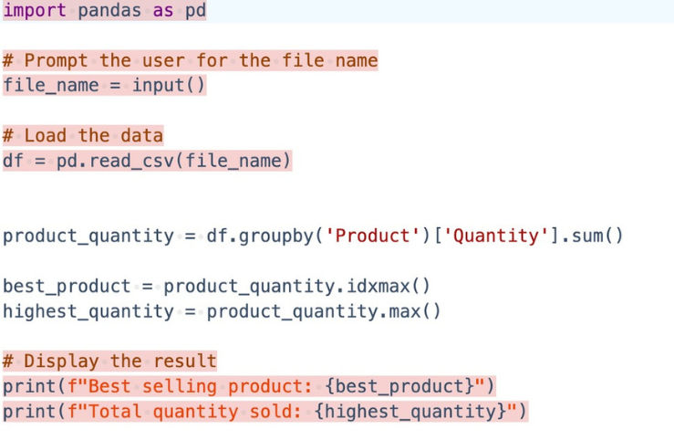

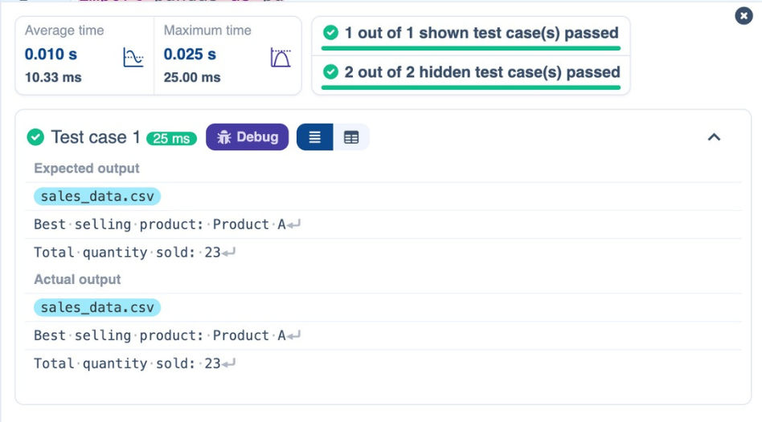


4.2.3. CITY THAT SOLD THE MOST PRODUCTS
Write a Python program that takes the file name of a CSV file as input, reads the data, and performs the following operations: The CSV file contains the columns: Date, Product, Quantity, Price, and City.
Group the data by City and calculate the total quantity of products sold for each city.
Find the city that sold the most products (based on the total quantity sold).
Sample Data:
Date,Product ,Quantity,Price,City
2025-01-01,Product A,5,20,New York
2025-01-01,Product B,3,15,Los Angeles
2025-01-02,Product A,7,20,New York
2025-01-02,Product C,4,30,Chicago
2025-01-03,Product B,2,15,Chicago
2025-01-03,Product A,8,20,Los Angeles
2025-01-04,Product C,6,30,New York
2025-01-04,Product B,5,15,Los Angeles
2025-01-05,Product A,3,20,Chicago
2025-01-05,Product C,10,30,Los Angeles

INPUT OUTPUT

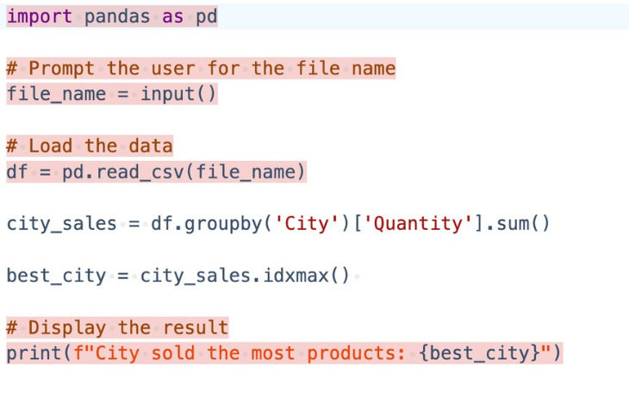

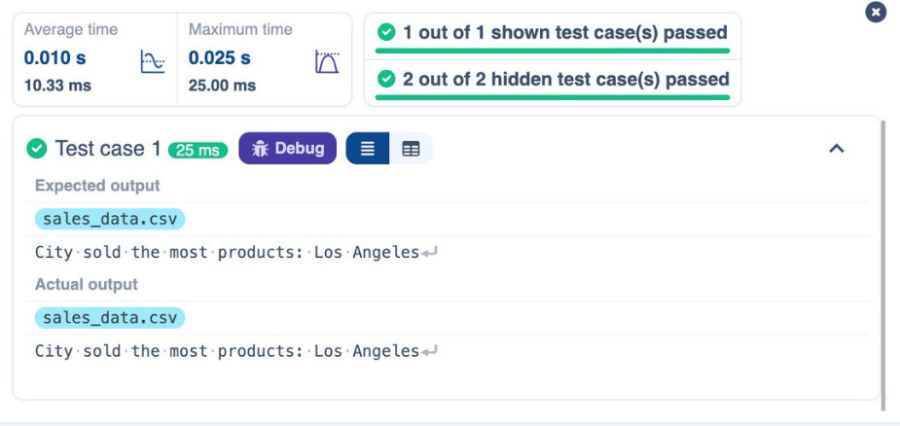


4.2.4. MOST FREQUENTLY SOLD PRODUCT PAIRS
Writea Python program that takes the filename ofaCSVfileasinput,reads thedata,andperformsthefollowingoperations: The CSV file contains the following columns: Date, Product,Quantity, Price,andCity.
For each date, find all pairs of products that were sold together(i.e., twoproductssoldonthesamedate). Output the product pair/s that was sold most frequently.
Sample Data:
Date,Product ,Quantity,Price,City
2025-01-01,Product A,5,20,New York
2025-01-01,Product B,3,15,Los Angeles
2025-01-02,Product A,7,20,New York
2025-01-02,Product C,4,30,Chicago
2025-01-03,Product B,2,15,Chicago
2025-01-03,Product A,8,20,Los Angeles
2025-01-04,Product C,6,30,New York
2025-01-04,Product B,5,15,Los Angeles
2025-01-05,Product A,3,20,Chicago
2025-01-05,Product C,10,30,Los Angeles
Explanation:
Transactions:
2025-01-01: Product A, Product B
2025-01-02: Product A, Product C
2025-01-03: Product B, Product A
2025-01-04: Product C, Product B
2025-01-05: Product A, Product C
Now, let's count how often the pairs of products appear together:
Product A and Product B: Appear in transactions on 2025-01-01 and 2025-01-03.
Product A and Product C: Appear in transactions on 2025-01-02 and 2025-01-05.
Product B and Product C: Appears in transactions on 2025-01-04.
Most Frequent Product Combinations:
Product A and Product B (2 times)
Product A and Product C (2 times)

INPUT OUTPUT

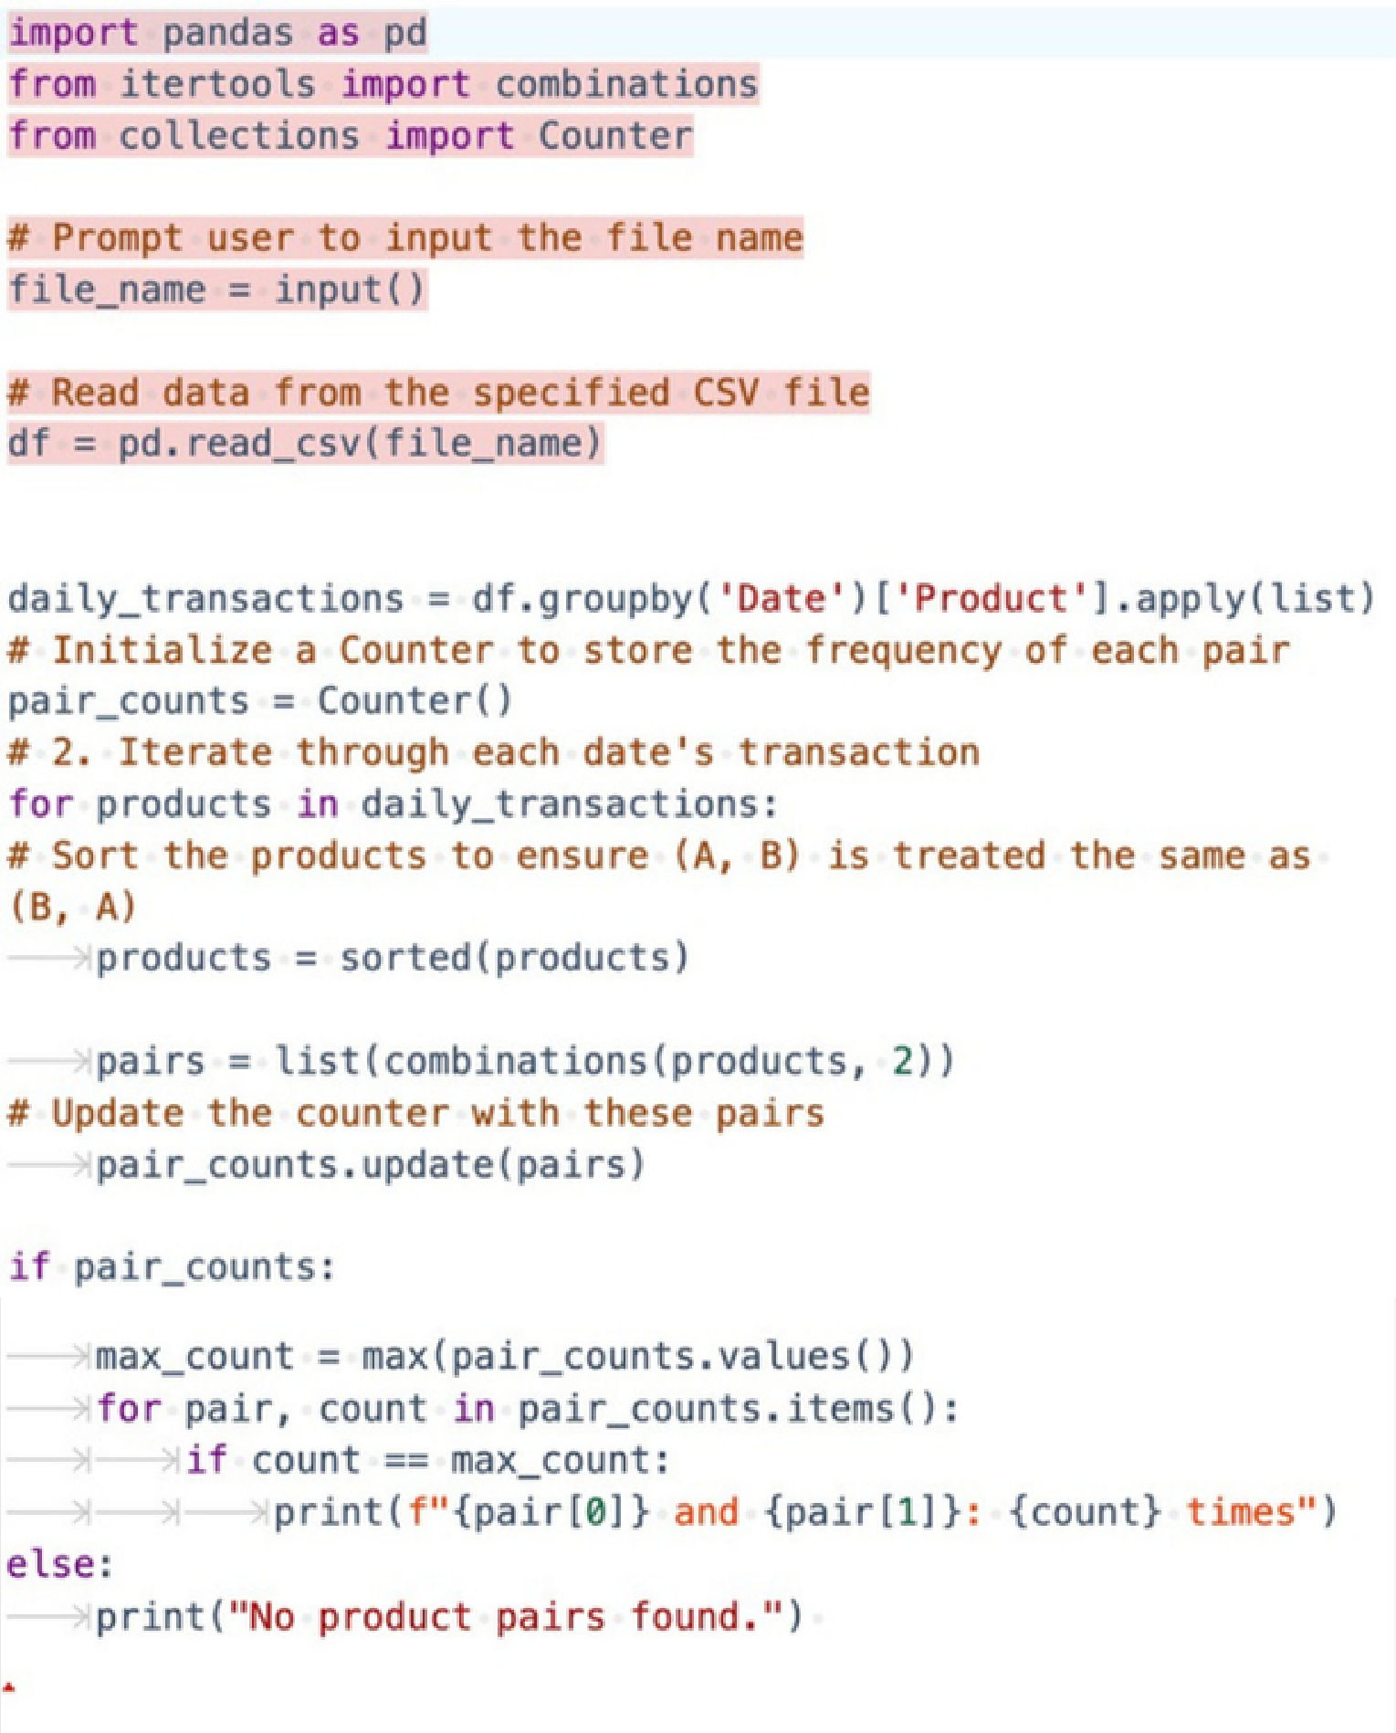

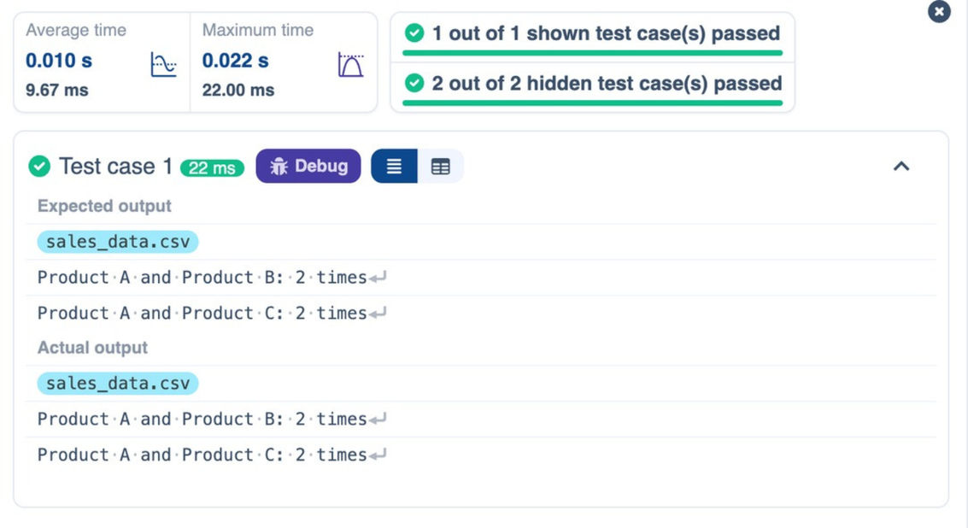

4.2.5. TITANIC DATASET ANALYSIS AND DATA CLEANING
basedonthedataset. For eachquestion,performnecessarydatacleaning,transformations,andcalculationsasrequired.
1.Display the first 5 rows of the dataset.
2.Display the last 5 rows of the dataset.
3.Get the shape of the dataset (number of rows and columns).
4.Get a summary of the dataset (using .info()).
5.Get basic statistics (mean, standard deviation, etc.) of the dataset using .describe().
6.Check for missing values and display the count of missing values for each column.
7.Fill missing values in the ‘Age’ column with the median age.
8.Fill missing values in the ‘Embarked’ column with the most frequent value (mode()).
9.Drop the ‘Cabin’ column due to many missing values.
10.Create a new column, 'FamilySize' by adding the 'SibSp' and 'Parch' columns.
The Titanic dataset contains columns as shown below,
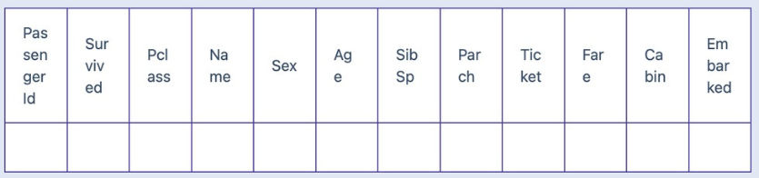
Sample Data:
PassengerId,Survived,Pclass,Name,Sex,Age,SibSp,Parch,Ticket,Fare,Cabin,Embarked
1,0,3,"Braund, Mr. Owen Harris",male,22,1,0,A/5 21171,7.25,,S
2,1,1,"Cumings, Mrs. John Bradley (Florence Briggs Thayer)",female,38,1,0,PC 17599,71.2833,C85,C 3,1,3,"Heikkinen, Miss. Laina",female,26,0,0,STON/O2. 3101282,7.925,,S
4,1,1,"Futrelle, Mrs. Jacques Heath (Lily May Peel)",female,35,1,0,113803,53.1,C123,S
5,0,3,"Allen, Mr. William Henry",male,35,0,0,373450,8.05,,S
6,0,3,"Moran, Mr. James",male,,0,0,330877,8.4583,,Q
7,0,1,"McCarthy, Mr. Timothy J",male,54,0,0,17463,51.8625,E46,S
8,0,3,"Palsson, Master. Gosta Leonard",male,2,3,1,349909,21.075,,S
9,1,3,"Johnson, Mrs. Oscar W (Elisabeth Vilhelmina Berg)",female,27,0,2,347742,11.1333,,S 10,1,2,"Nasser, Mrs. Nicholas (Adele Achem)",female,14,1,0,237736,30.0708,,C

INPUT OUTPUT
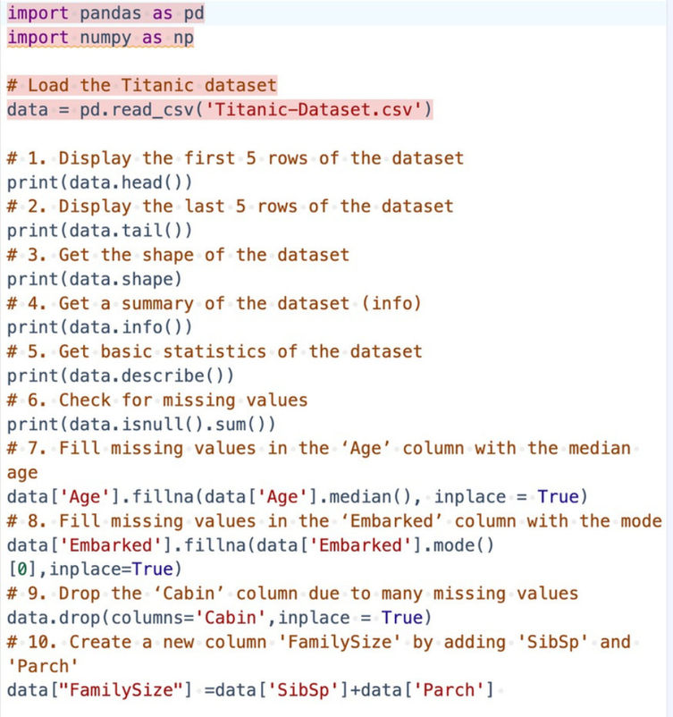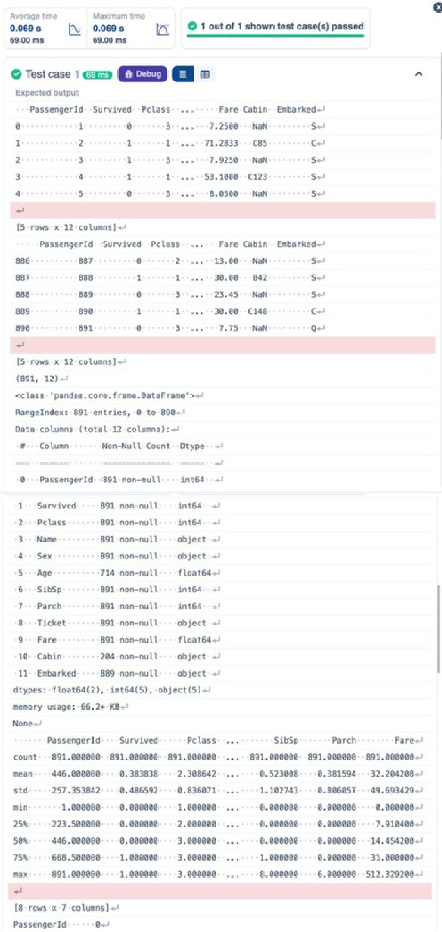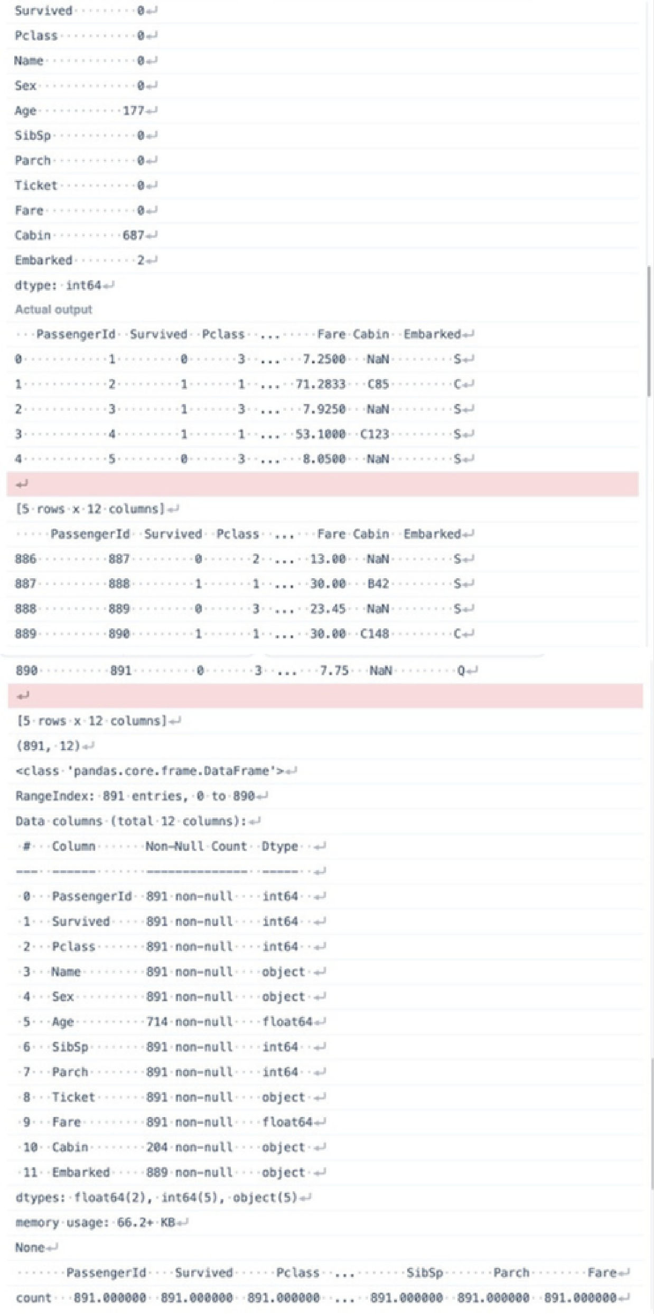

4.2.6. TITANIC DATASET ANALYSIS AND DATA CLEANING - 2
basedonthe dataset.
1.Createa new column ‘IsAlone’which is1 ifthepassengerisalone(FamilySize=0),otherwise0.
2.Convert the ‘Sex' columntonumeric values(male: 0,female:1).
3.One-hot encode the ‘Embarked’ column, dropping the first category.
4.Get the mean age of passengers.
5.Get the median fare of passengers.
6.Get the number of passengers by class.
7.Get the number of passengers by gender.
8.Get the number of passengers by survival status.
9.Calculate the survival rate of passengers.
10.Calculate the survival rate by gender.
The Titanic dataset contains columns as shown below,

Sample Data:
PassengerId,Survived,Pclass,Name,Sex,Age,SibSp,Parch,Ticket,Fare,Cabin,Embarked
1,0,3,"Braund, Mr. Owen Harris",male,22,1,0,A/5 21171,7.25,,S
2,1,1,"Cumings, Mrs. John Bradley (Florence Briggs Thayer)",female,38,1,0,PC 17599,71.2833,C85,C 3,1,3,"Heikkinen, Miss. Laina",female,26,0,0,STON/O2. 3101282,7.925,,S
4,1,1,"Futrelle, Mrs. Jacques Heath (Lily May Peel)",female,35,1,0,113803,53.1,C123,S
5,0,3,"Allen, Mr. William Henry",male,35,0,0,373450,8.05,,S
6,0,3,"Moran, Mr. James",male,,0,0,330877,8.4583,,Q
7,0,1,"McCarthy, Mr. Timothy J",male,54,0,0,17463,51.8625,E46,S
8,0,3,"Palsson, Master. Gosta Leonard",male,2,3,1,349909,21.075,,S
9,1,3,"Johnson, Mrs. Oscar W (Elisabeth Vilhelmina Berg)",female,27,0,2,347742,11.1333,,S 10,1,2,"Nasser, Mrs. Nicholas (Adele Achem)",female,14,1,0,237736,30.0708,,C

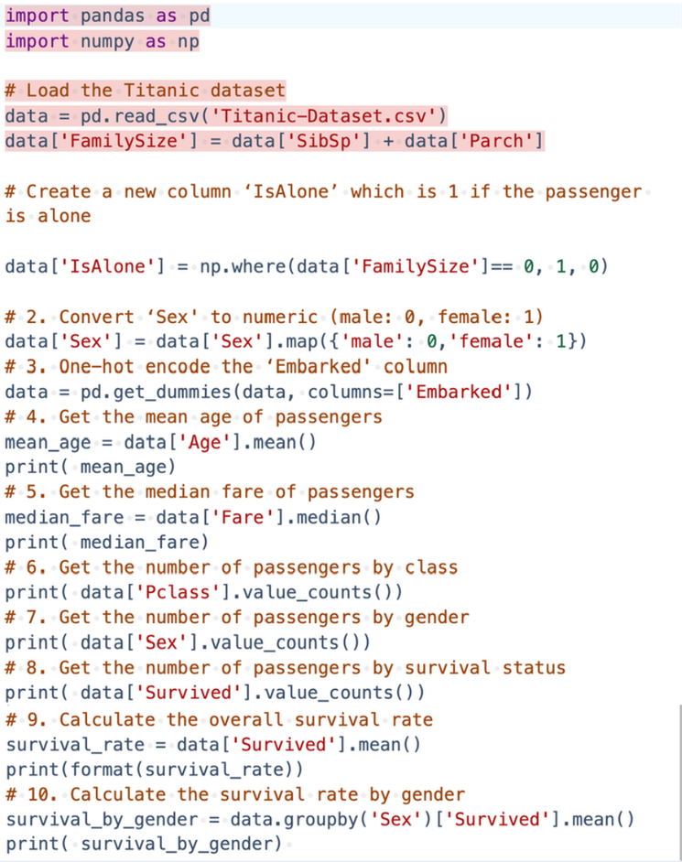

INPUT

OUTPUT
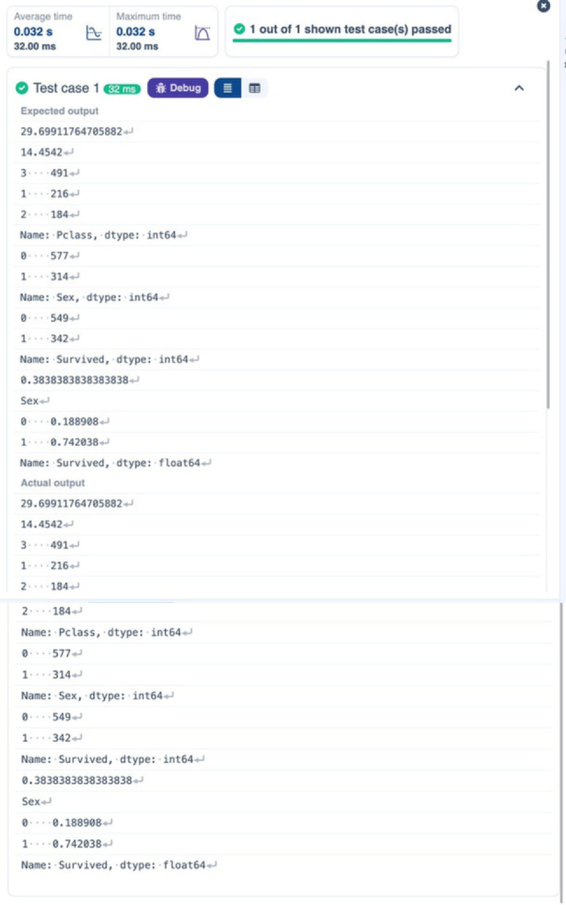

4.2.7. TITANIC DATASET ANALYSIS AND DATA CLEANING - 3
basedonthe dataset.
1.Calculate the survival rate by class.
2.Calculate the survival rate by embarkation location (Embarked_S).
3.Calculate the survival rate by family size (FamilySize).
4.Calculate the survival rate by being alone (IsAlone).
5.Get the average fare by passenger class (Pclass).
6.Get the average age by passenger class (Pclass).
7.Get the average age by survival status (Survived).
8.Get the average fare by survival status (Survived).
9.Get the number of survivors by class (Pclass).
10.Get the number of non-survivors by class (Pclass).
The Titanic dataset contains columns as shown below,

Sample Data:
PassengerId,Survived,Pclass,Name,Sex,Age,SibSp,Parch,Ticket,Fare,Cabin,Embarked
1,0,3,"Braund, Mr. Owen Harris",male,22,1,0,A/5 21171,7.25,,S
2,1,1,"Cumings, Mrs. John Bradley (Florence Briggs Thayer)",female,38,1,0,PC 17599,71.2833,C85,C 3,1,3,"Heikkinen, Miss. Laina",female,26,0,0,STON/O2. 3101282,7.925,,S
4,1,1,"Futrelle, Mrs. Jacques Heath (Lily May Peel)",female,35,1,0,113803,53.1,C123,S
5,0,3,"Allen, Mr. William Henry",male,35,0,0,373450,8.05,,S
6,0,3,"Moran, Mr. James",male,,0,0,330877,8.4583,,Q
7,0,1,"McCarthy, Mr. Timothy J",male,54,0,0,17463,51.8625,E46,S
8,0,3,"Palsson, Master. Gosta Leonard",male,2,3,1,349909,21.075,,S
9,1,3,"Johnson, Mrs. Oscar W (Elisabeth Vilhelmina Berg)",female,27,0,2,347742,11.1333,,S 10,1,2,"Nasser, Mrs. Nicholas (Adele Achem)",female,14,1,0,237736,30.0708,,C

INPUT OUTPUT
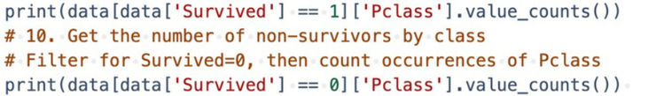
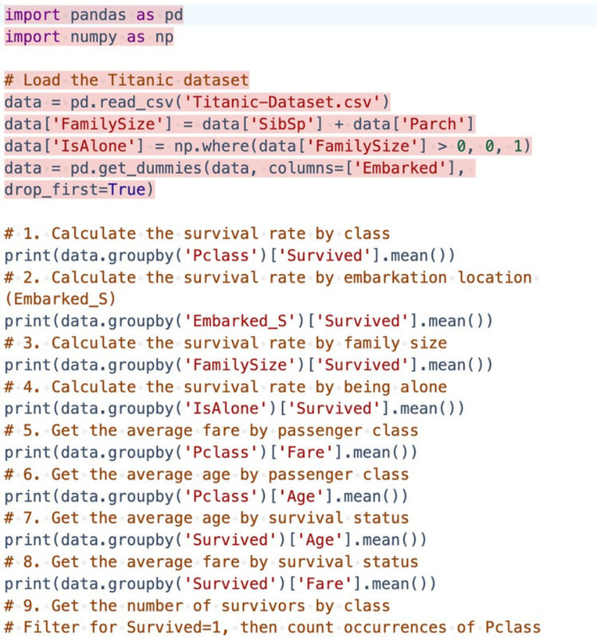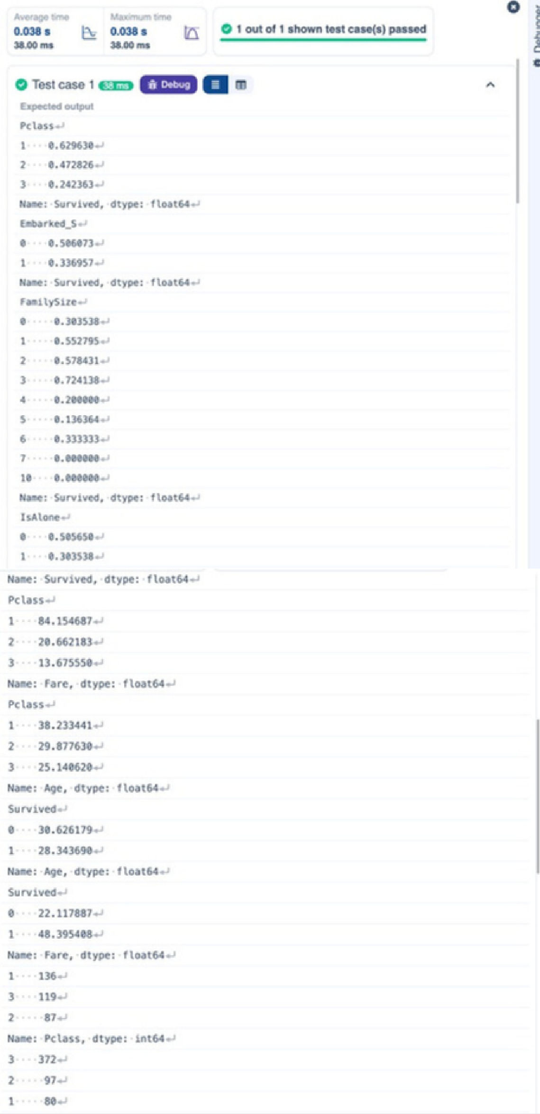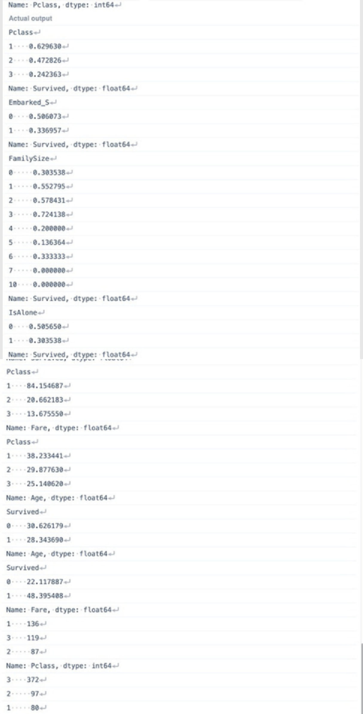

4.2.8. TITANIC DATASET ANALYSIS AND DATA CLEANING - 4
based onthedataset.
1.Get the number of survivors by gender(Sex).
2.Get the number of non-survivors by gender (Sex).
3.Get the number of survivors by embarkation location (Embarked_S).
4.Get the number of non-survivors by embarkation location (Embarked_S).
5.Calculate the percentage of children (Age < 18) who survived.
6.Calculate the percentage of adults (Age >= 18) who survived.
7.Get the median age of survivors.
8.Get the median age of non-survivors.
9.Get the median fare of survivors.
10.Get the median fare of non-survivors.
The Titanic dataset contains columns as shown below,

Sample Data:
PassengerId,Survived,Pclass,Name,Sex,Age,SibSp,Parch,Ticket,Fare,Cabin,Embarked
1,0,3,"Braund, Mr. Owen Harris",male,22,1,0,A/5 21171,7.25,,S
2,1,1,"Cumings, Mrs. John Bradley (Florence Briggs Thayer)",female,38,1,0,PC 17599,71.2833,C85,C 3,1,3,"Heikkinen, Miss. Laina",female,26,0,0,STON/O2. 3101282,7.925,,S
4,1,1,"Futrelle, Mrs. Jacques Heath (Lily May Peel)",female,35,1,0,113803,53.1,C123,S
5,0,3,"Allen, Mr. William Henry",male,35,0,0,373450,8.05,,S
6,0,3,"Moran, Mr. James",male,,0,0,330877,8.4583,,Q
7,0,1,"McCarthy, Mr. Timothy J",male,54,0,0,17463,51.8625,E46,S
8,0,3,"Palsson, Master. Gosta Leonard",male,2,3,1,349909,21.075,,S
9,1,3,"Johnson, Mrs. Oscar W (Elisabeth Vilhelmina Berg)",female,27,0,2,347742,11.1333,,S 10,1,2,"Nasser, Mrs. Nicholas (Adele Achem)",female,14,1,0,237736,30.0708,,C

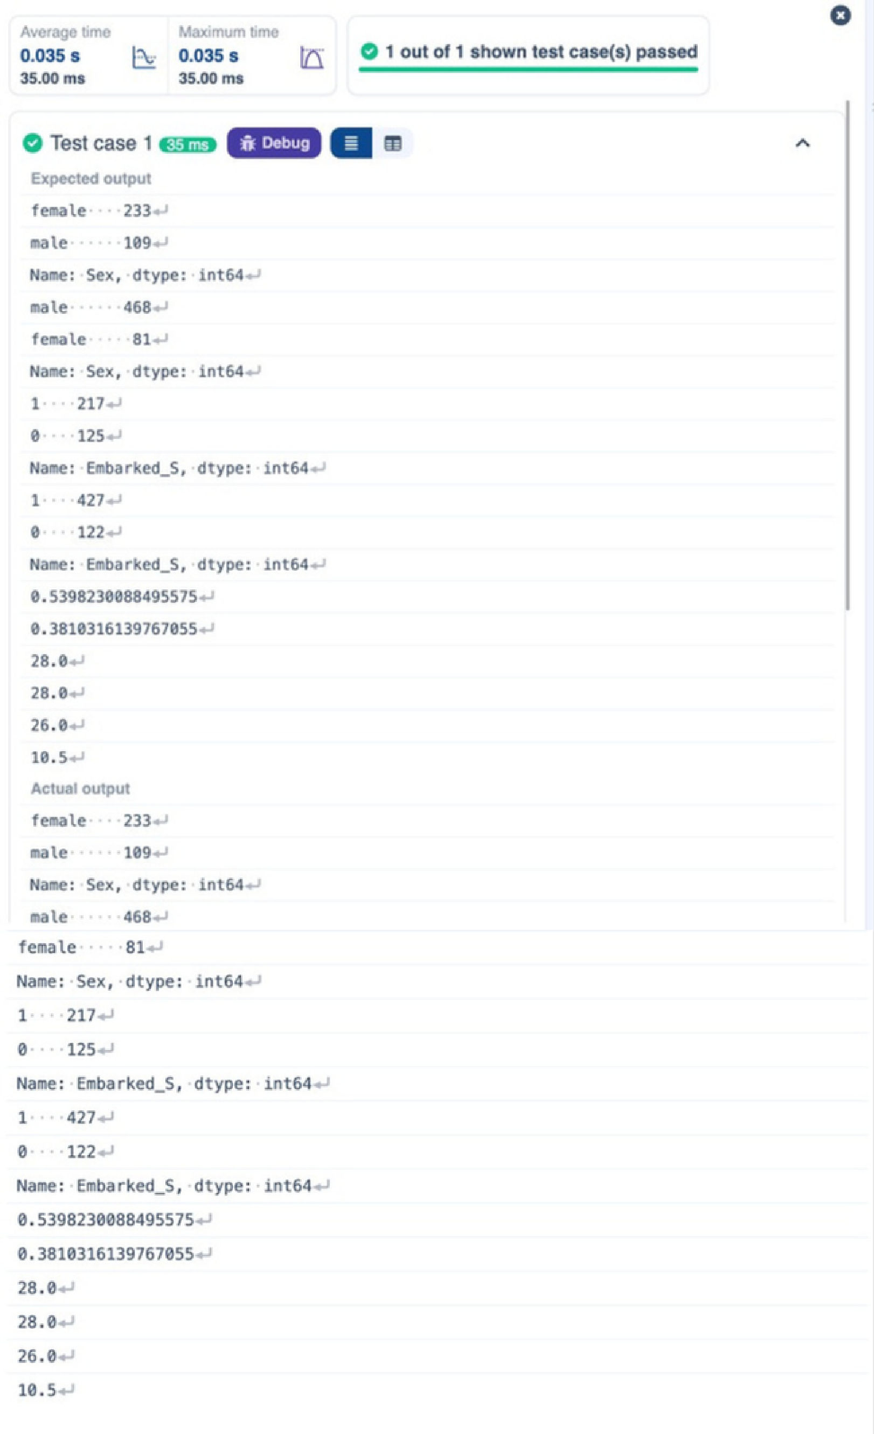

INPUT
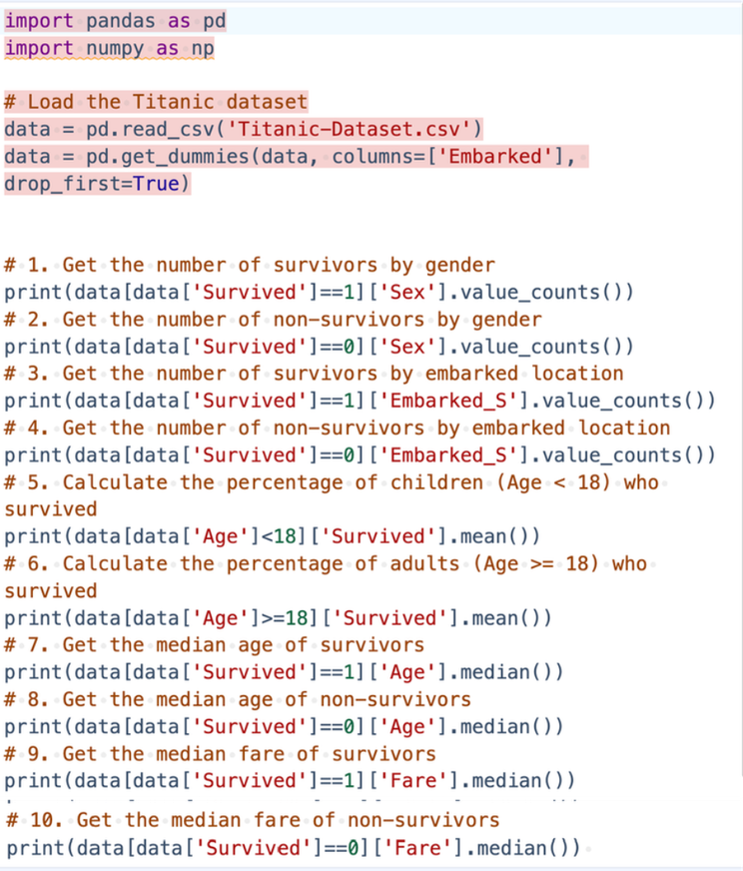

OUTPUT

